Documentation of Global Wind Module for CCTP FY08
August 1, 2008
Page Kyle

The representation of wind for CCTP FY08 has been modified from the CCSP representation. The latter assigned all technology and transmission costs in the resource, with backup costs assigned in the intermittent supplysector and zero costs in the technology. Now technology costs are assigned in the technology, backup costs are in the intermittent supplysector, and transmission costs are in the resource. As well, a second wind generation technology is included with emissions-free storage as a part of the technology; this has a higher capital cost but does not have to be backed up elsewhere in the electricity system.

The problem with the former representation (assigning all costs at the resource) is that the smooth resource curves were grossly underestimating the electricity costs at low deployment levels. The max-resources for wind are generally large (~500x the 2005 level of generation in the US) as there is a lot of land in most regions, and the prices at 50% of max-supply were kept equal to the values from the IEAGHG study in 2000 that had much lower max-resources. Because the resource curves pass through the origin (0,0 point), the cost drops to zero as deployment goes to zero. In addition to under-estimating costs, this creates model solution problems because the curve becomes increasingly vertical (large changes in supply for small changes in price) at low levels of supply.

Moving the costs to the technology solves the problem of cost underestimation, by setting a lowest possible cost below which the cost of wind can not drop. This cost is representative of the technology cost of a representative wind turbine at a class 4-5 wind site, with no charges for electricity transmission.

Turbine costs were taken from the EERE GRPA FY08 report; the costs were quite different from the AEO 2008 assumptions, and may be under-representing the costs. GRPA had $1167/kW in 2005, whereas AEO had about $1700 across three scenarios for new construction in 2010. Because the AEO costs also included transmission (accounted separately in our model), electric system upgrades (not assigned to electric generation technologies in our model), and non-economic factors such as the valuation of aesthetic losses, the GRPA costs were used. But the transmission costs calculated do not begin to approach the cost discrepancy between these two data sources, and in the future it may be worthwhile to look into what exactly accounts for the large discrepancy in assumed wind turbine costs between the two offices in DOE.

The turbine assumed is a representative class 4-5 turbine, with costs declining at 0.25% per year in the reference and 0.5% per year in the advanced scenarios. Because the technology is mature compared to the other renewables, the costs do not decline as sharply; this is in accord with both the AEO and the GRPA. No substation costs were assessed. Capacity factors were assumed to start at 44% and increase to 48% in the reference and 52% in the advanced; it isn’t clear what this stands for, but both the GRPA and AEO assume capacity factors will increase over time. It seems that as less windy resources are used over time, one would expect the capacity factors to decline. The AEO’s justification is that technological improvements dealing with turbines and with systems management allow higher rates of conversion from wind energy to electric energy. The GRPA has turbines getting larger over time, so perhaps this accounts for some of the capacity factor increase.

Technology costs calculations are straightforward. The turbine capital costs are levelized over a 30 year lifetime with a 12.5% capital charge rate, the same as is used for all renewables in MiniCAM. O&M costs are added to calculate an annual, per-kW cost. The annual output is calculated as the number of hours in the year (multiplied by one kW) multiplied by the capacity factor. The dollar amounts are converted to 1975$, and the output is converted to GJ for the non-energy cost in MiniCAM.

Backup costs are the same as before. Resource costs are a bit more complicated. For this, the spreadsheet model of wind developed by Steve Smith and Dan Barrie was used, to inform the average transmission distances of available wind resources in the U.S. This is based on the same data as is used in the detailed U.S. wind module, documented elsewhere. In summary, the data from this study was used to generate a supply curve for each wind speed class from classes 4 through 7, of available generation as a function of distance to grid. No preference for wind speed classes was given in this process; available Class 4 generation was worth just as much as available Class 6 generation. The classes only differed in electricity generation per unit of land, as reflected in assumed capacity factors (50% for class 4 to 60% for class 7). While the capacity factors in the spreadsheet seemed high, they weren’t changed as all they are used for in this study is relative generation. Actual maximum resources input to MiniCAM are calculated separately.

The distances were converted to dollars, based on an assumed $1,125 per MW/km/yr of transmission cost. This is the mid-point of costs used by NREL ($1600 to $2000 per MW/mi/yr). This divides through to $1.125 per kW/km, and because this cost reflects capacity (whereas inputs to MiniCAM are based on actual electricity delivered), it is divided by an assumed 45% capacity factor in converting this to 1975$/GJ. This allowed a supply curve to be generated; the supply curve was used in calculating smooth-resource parameters (curve-exponenet and mid-price) for input to MiniCAM.

Steve Smith calculated the max-resources for each region according to the following equation:

Available resource = US Multiplier * Total land area / Available land area
US Multiplier = max-resource in JGCRI detailed US wind model / IEA estimate
Total land area = total land area in each region
Available land area = land area not excluded to wind development

The max-resource was taken from the detailed US study.

The Data Manipulator was used to process GIS data of land areas and other information relevant to setting exclusion criteria for wind development. There was a population threshold and a forested land threshold, and possibly another one notated by the letters “GT.” The assumption behind the equation was that the IEA wasn’t informing their supply curves by actual available land, but rather by total land area in each region multiplied by a very low (0.15 MW/km2) turbine density. We use 5 MW/km2 in the detailed US model.

Afterward (August 28, 2008)

NREL just released a report called 20% by 2030, detailing the technical capacity of wind energy to supply 20% of US electricity by 2030. The report presents a number of assumptions on wind costs and transmission costs, and our transmission costs have been updated to use these numbers. We don’t use their capital costs for wind turbines, which are high to reflect present shortages and high materials prices. The report also presents assumptions of non-wind generation sources and across the boards, their numbers are a good deal higher than what we have in our model. Excerpted from an email:

tech us NREL
Wind 1150 1650
Gas combustion turbine 492 625
Gas combined cycle 725 780
Coal conv 1545 2120 (assumes SO2 and NOx controls)
Coal IGCC 1791 2750
Nuclear 2300 3260

What is important is that our costs for different generation technologies remain consistent relative to one another; using the higher figure for wind without also bumping up coal and nuclear would create problems, and we don’t want to switch all of our techs to these higher costs because (a) there is little benefit, and (b) our numbers are based on a reliable, transparent source commonly used in MiniCAM (NEMS). These numbers are actually from a consulting firm (Black & Veatch) contracted by NREL, and as such aren’t transparent in their derivation.

However, their transmission line costs are used. They started with one similar assumption: $1600/MW-mi. However, they assume that connection to a local grid is only adequate 10% of the time, because most lines in the US won’t have excess capacity for a wind generation plant to use. The remaining 90% of future wind farms will have to connect to a load center or do long-distance transmission between sub-regions. Because of the complexity of the issue, we are using their supply curve for our resource curve, setting their zero-capacity point equal to zero cost. This means that a base “technology cost” is used, regardless of how little the deployment is. Additional costs due to transmission (or other costs addressed in the NREL study) are in the resource. This is illustrated in the graph here:
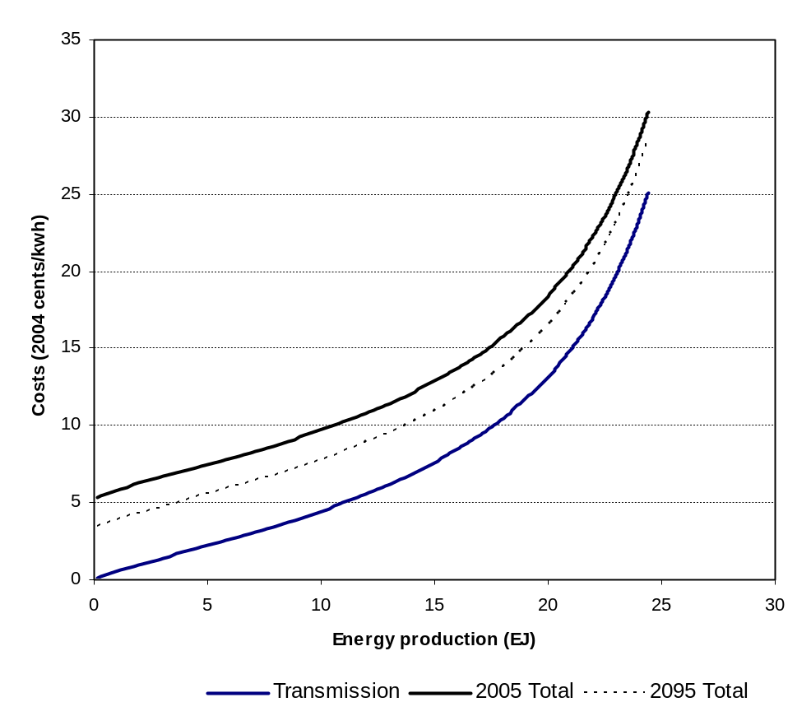

This newer representation actually has transmission costs increasing with deployment; looking only at grid connection, the costs from 0 to 29EJ of resource only increased by about 1 cent per kwh.

The final change that has been made is the inclusion of a storage option on-site at a wind farm. The representative technology has the characteristics (lifetime, costs) of a lead acid battery, and the fraction (kW wind to kW battery) required for the purpose of backup is an input parameter in the workbook. It isn’t known at this point what a good estimate would be; backing up each kW of wind turbine with 1kW of battery may be inadequate as the batteries can only run for one hour. 10x the number might be a better choice. The costs will be sensitive to this parameter.

Because of the losses associated with charging a battery and discharging, a whole-system efficiency is estimated based on an 80% round-trip efficiency (EPRI-DOE Handbook of Energy Storage, 2003), and a 10% capacity factor. A higher capacity factor is assumed for the battery than for a standard backup generator for the whole system because it is assumed that the battery is used for more local backup, and is thus more sensitive to the variability of local conditions. However, the value might still be low. This has the effect of lowering the efficiency of the whole operation by 3%.

